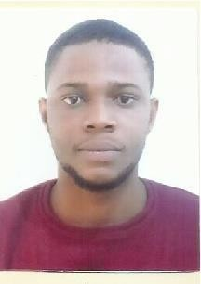**CURRICULUM VITAE**

Name : Akupuome, Ikenna Blaise Email : [ikenna@uni-bremen,de](mailto:akupuomeikenna@gmail.com) Mobile Number : +491783019032

<https://www.linkedin.com/in/ikenna-akupuome-a4a7b991/>

<http://blaiseik.epizy.com/>

(Test Website)

**OBJECTIVE**

  To obtain a challenging Front End Developer’s position where my education and work experience will have valuable application.

EDUCATION

2019-Present Master of Communication and Information Technology University of Bremen, Germany.

2007-2012 Bachelor of Engineering Electrical Electronics Madonna University Nigeria (4.14/ 5.00)

1996 – 2001 Primary School Education at Foundation Nursery and Primary School Ovwian Delta State, Nigeria.

**WORK EXPERIENCE**

August 2014 – February 2019, Jofaad Global Services Limited

* Junior PLC maintenance Engineer
* Fabrication of Solar Panels and street Lights.
* Overhaul of Industrial machines and Technical equipment’s April 2013- April 2014 National youth service Corp NYSC-
* Physics and Mathematics Tutor for Senior Secondary School Students September 2012- March 2013 Petroleum Training Institute Warri, Nigeria
* Power Trainee mainly involved in maintenance and overhaul of industrial equipment’s, high voltage testers and solar lighting systems

**CORE SKILLS**

HTML, CSS and Javascript

Basic Knowledge of React Framework

Electronics

**SHORT TERM PROFESSIONAL GOALS**

Certified Frontend Developer

Certified Cisco Network Engineer